**Shunt Voltage Regulator**

**Load Regulation**

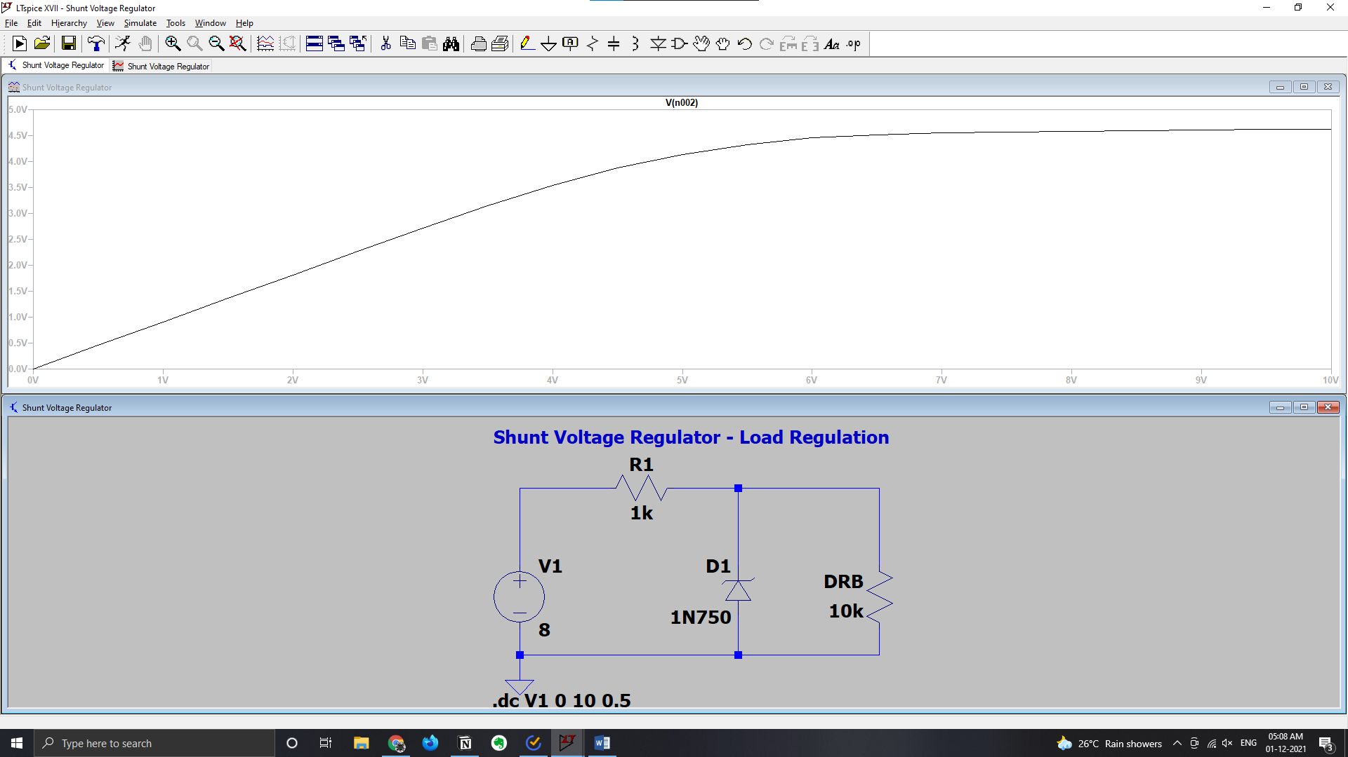

**Line Regulation**

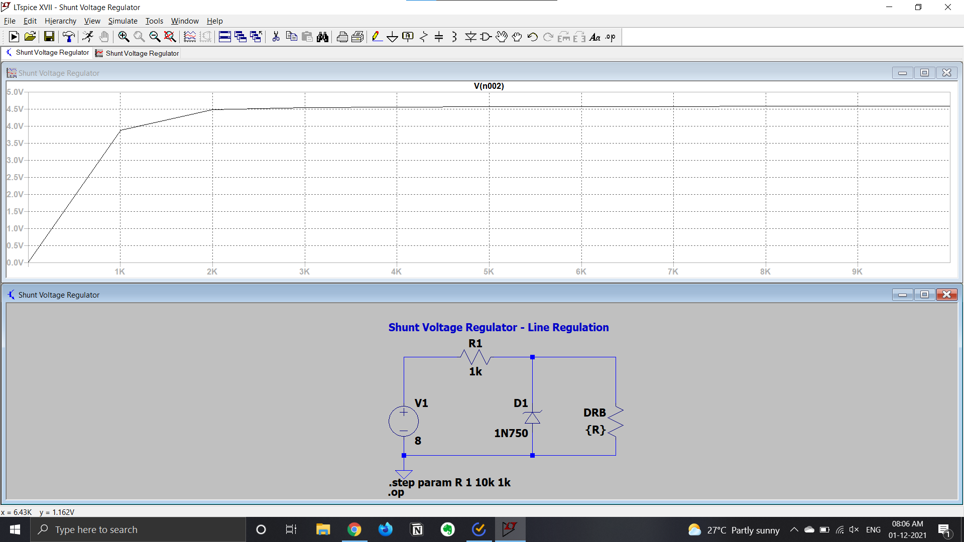

**Series Voltage Regulator**

**Line Regulation**

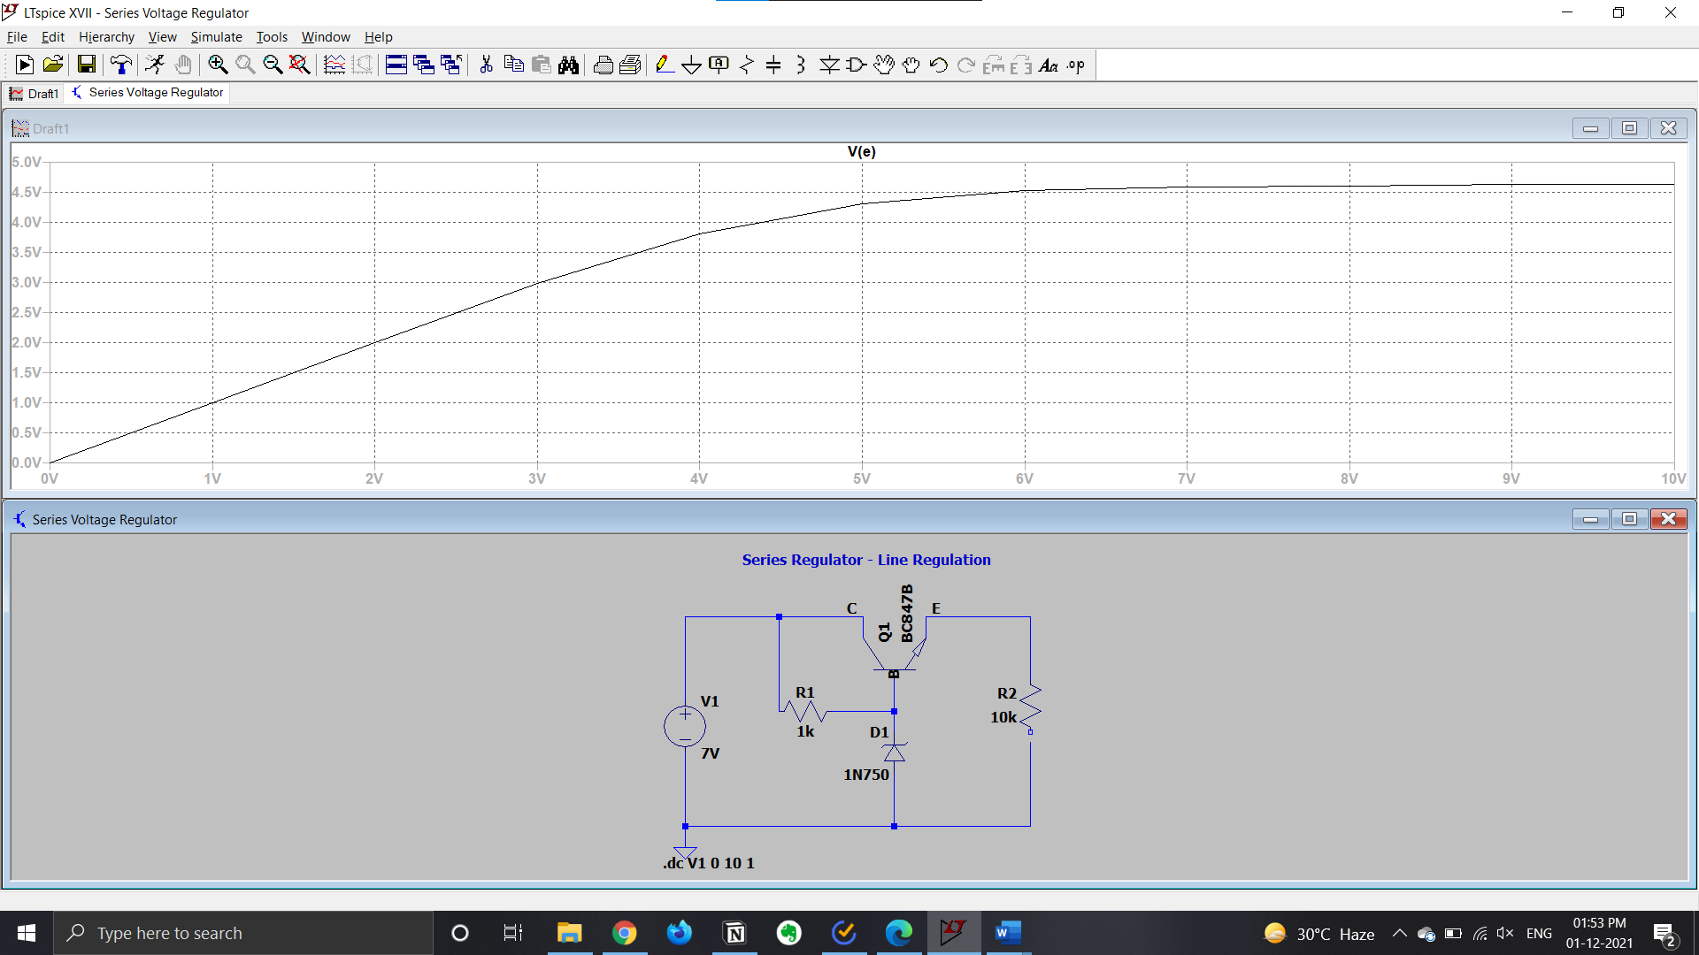

**Load Regulation**

